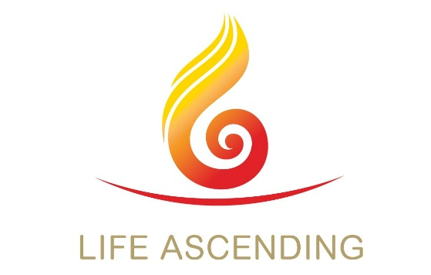

**Our Lady’s Ascent Group**

**Members of “La Vie Montante Internationale”**

**Annual Report 2024/25**

Our group started over 20 years ago and meets about 22 times each year, on the second and fourth Tuesdays of each month after 10.00am Mass.

**‘La Vie Montante’** is a confraternity or organisation of the Catholic Church. The words have been translated into English as **‘Life Ascending’** but ‘montante’ means more in French (rising up, improving, growing, increasing or abounding) and brings to mind the Scripture of *John 10:10 “I have come that you may have life and have it in abundance”.* In the last year we have worked hard on the threefold aims set for us; **Spirituality, Friendship and Mission.**

At the core and main focus of Life Ascending; **Spirituality** is in essence how we relate to God the Father, the Creator, how each of us maintains a direct and personal relationship with Jesus, the Son, the Word, Holy Scripture and the power of the Holy Spirit who helps us understand and recognise the gifts of Faith we have been given. At each of our meetings we always pray together and often read and share Scripture passages appropriate to the season. We also invite visiting speakers to share their Faith and to teach us.

In October 2024 we hosted all the Southwark Diocese Life Ascending Groups, for a morning of Reflection on prayer and after lunch a Reflection on *Matt.6:7-15* *[The Lords Prayer.* We were encouraged to pray slowly in order to increase our understanding of the words and we ended by saying together the ‘Our Father’, each in our own mother tongue [perhaps 8 or 10 different languages].

In *John 15:15*, Jesus himself tells us we are not servants but his friends. So, **Friendship** is something which comes naturally and easy but it’s not simply breaking our fast with tea and biscuits after mass but being able to share our hopes, joys and even our fears with one another. We pray together and also find that we come closer by reading and sharing our thoughts on Scripture, in different ways.

**Mission** is the Church’s reason for being [*Matt 28:16-20 The Great Commission]*. Last year we helped Sr. Pat DMJ by providing a paddle sewing machine for use by her ladies group in Northern Cameroon. We also supported Deacon Sean, on his personal mission in Ghana. However, our personal Mission spreading the Good News of Jesus Christ, continues to be a struggle. Although we make every effort to bring the Gospel message into our daily lives, we have difficulty keeping our numbers up and recruiting members within the parish, and we are not well enough trained or experienced in Evangelisation to go outside.

Over the year we arranged for six outside speakers; three Sisters, two Deacons and a Priest who talked and shared with us. These were supplemented by four of our own ladies and two of our men, who led our meetings, bared their souls and witnessed to us by sharing the details of their personal Journeys to Faith. We have acquired CaFé and Sycamore videos to help illustrate talks on St. Patrick and St. Benedict of Nursia and often read and share the Sunday Gospels.

**Perhaps the highlight of the year** was our Groups Ecumenical effort in May 2025. On an ‘Awayday’ after morning Mass, we went on a mini pilgrimage to visit and pray and read from St Luke’s Gospel of the Annunciation, in two Norman churches established over 900 years ago in 1080 -1086. Both were Catholic Churches for some 500 years and are still dedicated to Our Lady. In St. Marys Church Farleigh, with stone walls 3 feet thick and a very small congregation, we learnt that their bells had been replaced in 1647 because the originals, together with all the Church valuables had been confiscated by King Henry VIII. First, we read from *Luke 1: 26-38* *[The Annunciation]* and then *verses 39-46 [the Visitation to Elizabeth*]. It was an uncanny feeling to read the very same scriptures which had no doubt been read by people at the dedication of the Church 929 years before. Finally, we prayed the Angelus at midday. In Addington village, the Church of St. Mary the Blessed Virgin was obviously generously provided for, well maintained and supported by a larger congregation, but perhaps only 10-15% of our own. There we read *St. Luke’s Gospel 1:46-56 [The Magnificat]* and sang ‘Tell out my soul’ which is based on it.

**Although Life Ascending International focuses on supporting those who are retired or soon to retire [ages generally 55 and upwards] we are open to everyone on Tuesdays after 10.00am Mass. We would of course always welcome younger parishioners to join, to help us and themselves to share and grow our Catholic Faith.**

Retired or near Retirement?

Catholic?

* Spirituality *

* Friendship *

* Mission *