**Second Sunday Coffee Mornings**

**July 24- June 25**

Thanks to our parishioners for vibrant, engaged and every Second Sunday of the month. This highlights the significance of social gatherings, particularly those that occur after Mass as recognised by the Synod  that faith is not solely expressed through formal worship but also through the bonds of fellowship and shared life strengthened in moments of social interaction.

Thanks to the volunteers on the Second Sunday Coffee morning: Nike, Rosa, Sheila, Michelle. Rosa is the chief baker and is regularly complimented for her cakes.

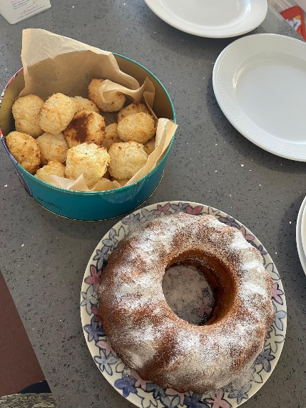The Second Sunday Coffee morning provided a welcoming atmosphere and a valuable opportunity for parishioners and their families to :

* build relationships and make new friends,
* strengthen their faith through having casual conversations,

chat sharing experiences, discussing beliefs in our lovely Hall after Mass

* being a model and attract others to participate in Church and parish

activities.

* support charities and being generous

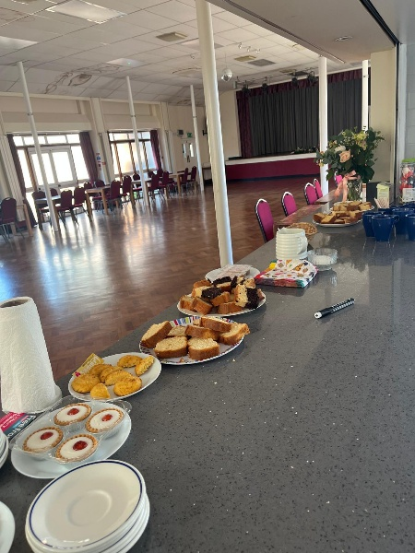 Stand out moments this year were the two coffee mornings led by the Coloma students (daughters of parishioners) who wanted to do some volunteering for Duke of Edinburgh Award. They also raised money for guide dog charity.

All donations are distributed to various charities and causes.

* £200 went to the Clergy Support Fund from (July to December)
* A donation of £90.71 to a project in Ile Ife, Nigeria ( July to December)
* £220 donated in March and April to support a year 13 parishioner's registration to Cancer Moonwalk; she raised £217 for the charity
* £140 raised for Croydon refugee Centre led Sonya in May, one of our mother and toddler group parishioners.
* £100 donated to the church

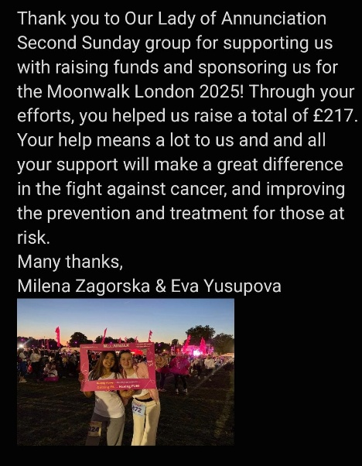

**Golden Pennies 2024**

The golden pennies jars raised £60 and this was donated to Croydon Nightwatch. The next count will be in December 2025, so please fill and send in your ‘golden pennies’ jars.