**Foodbank Collections**

**Organisation & Delivery**

**Recycling for charity**

**Stamps, Printer Cartridges etc.**

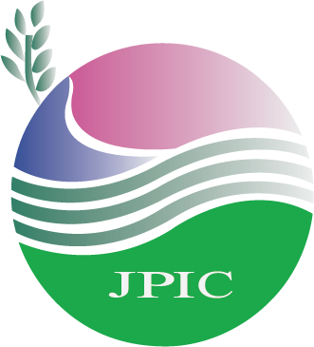**Justice & Peace**

**Interested in helping with any of these?**

**Ask a member of the PPC for details**