**St Thomas Becket School have been busy designing a mosaic to commemorate the**

**Jubilee centenary of the Church**

We are working with a professional mosaic artist, and will be mounting the mosaic in the space above the porch outside the church building.

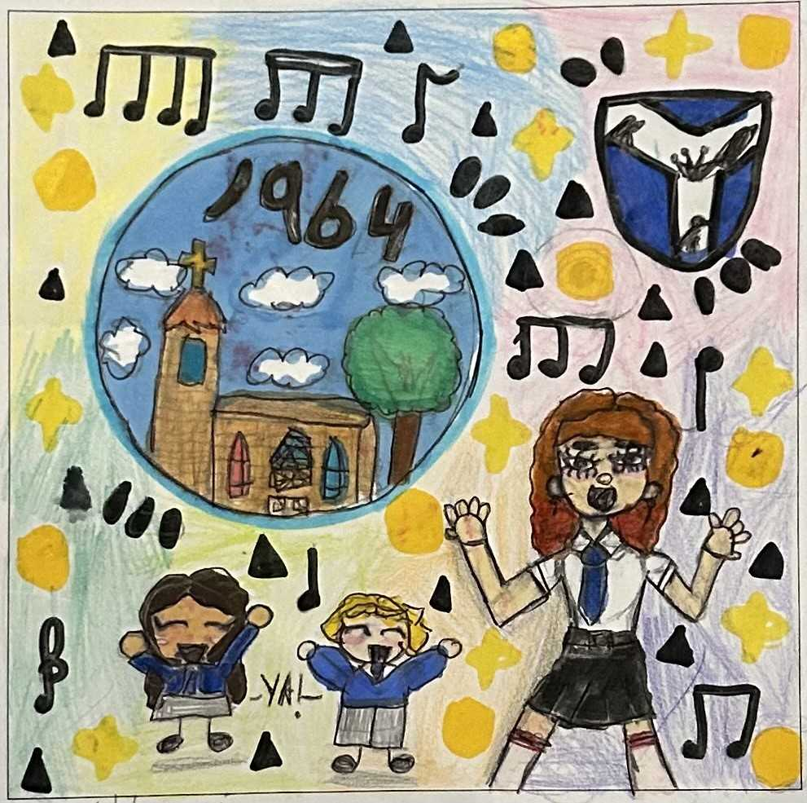

**To help raise money for this, we will be selling our school CD, with songs from 1964 to commemorate the modern church building's 60th Anniversary**

CDs will be on sale at the Parish picnic

along with a choir performance.

**CDs - with QR code download can be purchased for £10**