Addiscombe Union of Catholic Mothers

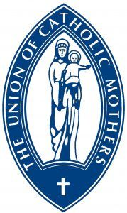

Come and join us!

We welcome all women in the parish to join us on the 1st Wednesday of each month at 8pm in the large hall for our monthly meeting. We have talks from a wide variety of speakers and enjoy social time and activities together. We play an active role in the parish, supporting parish functions and events and have raised thousands of pounds for both local and nationwide charities selected by members. We have a monthly Mass on 1st Sunday of the month and host the coffee morning after this Mass to help support the work we do.

Who we are
The UCM in Addiscombe is part of a National Organisation of Catholic Women, open to all women who support our aims and objectives in 'prayer, love and active witness to marriage, family and Christian life in the world' (from our membership prayer). We have over 30 members in Addiscombe and cover a wide range of ages and backgrounds, all are welcome!

For more information email ucmaddiscombe@gmail.com

What we do nationwide
For over 100 years, we have been involved in current affairs, particularly those that impact on family life, lobbying our politicians to protect the marginalised and vulnerable in society both home and abroad. We are affiliated to other likeminded organisations, are active in our parishes and support each other in love and prayer.

Aims & Objectives
- To help Catholic women to appreciate the Sacramental character, responsibilities and permanence of marriage and to live in unselfish love observing the laws of God and His Church.
- To assist them to bring up their children as practising Catholics and public-spirited citizens.
- To teach and defend Christian values in family life and to ensure Catholic education for future generations.
- To offer love, sympathy and practical help to the family in difficulty.

Addiscombe Union of Catholic Mothers

Events 2025

5th July – Summer Social

3rd September - Autumn Fayre preparations

1st October – Mary’s Meals Talk

10th October – Quiz Night

5th November – Sister Sheila

3rd December – Christmas Craft and cocktails

Come and join us!

