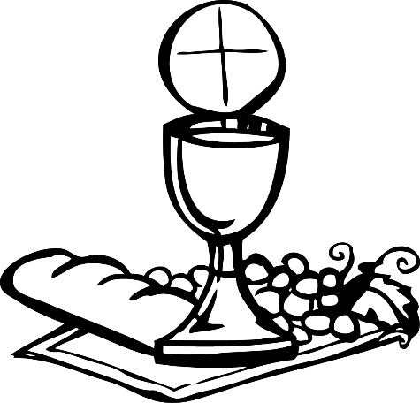

**PRAYERS**

**RENEWAL OF BAPTISMAL PROMISES**

These are the promises, which you made on behalf of your child on their Baptism day. Your child is now able to say this prayer with you…

We believe….

in God, our Father almighty,

creator of heaven and earth.

We believe…

in Jesus Christ, Our Lord:

the only son of God, who

died to save us.

We believe…

in the Holy Spirit who lives

with us now and for ever

Amen.

This is our faith

This is the faith of our

Church.

We are proud to believe

**OTHER NEWS**

The next **Parents meeting** will be next week on **Tuesday, 25th January at 8pm** in the church. The meeting will be about the sacrament of reconciliation.

The ‘I belong’ book, please encourage your child to make this book their own by colouring, sticking in photos and making it a personal record of their Journey.

We will use this news letter each week to let you know what we have been doing in class and which pages in the book we have been looking at.

I am aware some parents may have not received the Parents Guide book but we will get this to you as soon as they are posted to us.

If you have any questions or concerns then please contact

Cherie - 07525224423

**Welcome…**

Happy New Year and welcome to the continuing journey towards your child’s Reconciliation and First Holy Communion. You should receive the Parents Guide book as well as your child’s I Belong book.

This week we have talked about the importance of names and listened to stories in the Old Testament and the New Testament that show the importance of names; Adam names the animals in the story of creation and Jesus is named as Gods Sons at his baptism. We then began to think about our own baptism and how we were named. It is at Baptism we become part of Gods family; it is the first stepping-stone on our special journey towards meeting Him in First Holy Communion.

During the week it would be helpful if you could find an opportunity to talk to your child about his or her own Baptism or another Baptism, which they may have experienced. Please look at pages 2 to 10 and ask your child to fill in the pages.

10th January 2022

**Communion News**

Our Lady of The Annunciation