Our Lady of The Annunciation

Our Lady of The Annunciation

**Communion News**

14 June 2021

**OTHER NEWS**

**Attendance**

Time is steadily flowing, we only have three more sessions before the children take the sacrament of First Holy Communion. Please ensure your child/children attend the remaining sessions and complete the chapters in the book each week.

If your child is unable to attend, please inform me or ring the church office.

**Rehearsals**

Rehearsals for those receiving First Holy Communion on Saturday, 10th July will be on Wednesday, 7th July at 6 pm and rehearsals for those receiving First Holy Communion on Sunday, 11th July will be on Thursday, 8th July at 6 pm in the church.

Contact details:

Cherie 075252243

**This Week**

This week we have moved on to the chapters “Bread to Offer” and “Fruit of the Vine”

Last week we learned about the first part of the mass, “Liturgy of the Word” and now the second part “Liturgy of the Eucharist”.

In these chapters we are thinking about how when we gather to celebrate Mass, we are remembering Jesus celebrating the last supper.

We talked about preparing the altar table for the special meal; and how helpers offer the priest our gifts of bread and wine, (offertory). Those gifts show our thankfulness for all the gifts of the earth that God has given you.

At class, we laid out a table ready for a party and laid out a special table ready for mass. We looked at how the two compare. In this way, the children understand that when we go to mass, Jesus invites us to share a special meal with him.

During the class, we acted the first miracle in Cana and Jesus fed the 5000 and thought about how God has given us 2 kinds of food, He gives us food for our bodies to keep us strong and healthy, and he has given us food for out hearts to help us to go out each day and share Gods love with all we meet.

Please complete pages **68- 92**

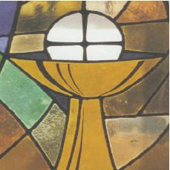

Prayer

We often forget to thank Jesus for our food. As a family you might consider saying a prayer together before you eat, particularly at celebratory times. Giving thanks for food also reminds us of those who are hungry and have much less than we do.

Perhaps you could use this or write your own, with your children.

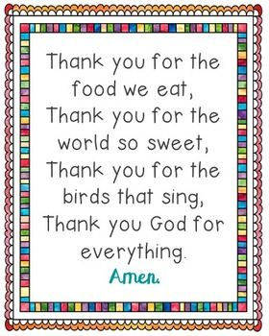

**Thank you for the food we eat… yum, yum!**

**Thank you for the friends we meet…. ho, hum!**

**Thank you for the birds that .. sing – a – ling – a – ling!**

**Thank you God for everything!**

God O