Our Lady of The Annunciation
Our Lady of The Annunciation
COMMUNION NEWS
28th June 2011

OTHER NEWS

Final Session

The children do not need to bring their books for next week classes as they will be involved in making their banners that will be displayed on the day of their First Holy Communion. We will be taking the children to church so Father Keith can explain and show the children what goes on in the life of the church.
You will need to collect your child from church at 6.45.
.

Communion masses

On the day of their Holy Communion, you need to take your child to the Hall 15 minutes before mass begins. Please also ensure that they have been to the toilet before arriving at church.
If anyone requires Wheelchair Access for their child’s Holy Communion Mass, please let me know in advance.

Communion Wear

There are no fixed rules for the dress code for communion but regarding the girls, the colour white and ivory are popular but it is up to family choice.
Accessories such as; gloves, bags, Rosary beads, or umbrellas, or anything else that may be carried, are not allowed in the communion mass. Whilst receiving communion, children should have nothing on or in their hands.

Contact: Cherie 07525224423

This Week

This week we continue the chapter “Body of Christ”
We have practiced receiving an unconsecrated host and will do this again next week, so the children get familiar how to receive Holy Communion.

When receiving Communion in our hands, left over right, we say “Amen” in response to the words “The Body of Christ”. The children are told that on their first Holy Communion day they will actually be receiving Jesus’ body.
Receiving Jesus in Holy Communion is one of the ways in which Jesus keeps his promise to be with us always.

We have also covered the final chapter ‘To Love and to Serve”
We would like the children to make every effort to complete their books up to page 129.

The children also took part in a quiz about all we have covered over the last 3 months and we were pleasantly surprised how well most of them remembered what was covered. Well Done!!

.

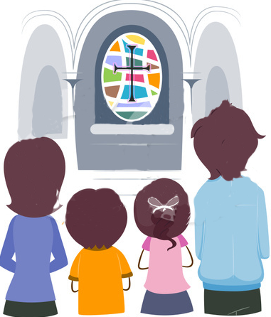

Prayer
Father In Heaven, you give us Jesus to be the Bread of Life and Cup of Salvation.
We thank you for your great love, and we ask you to make us loving too, through Christ Our lord, Amen.

God O
Prayer

Hail Mary, full of grace the Lord is with you.

Blessed are you among women and blessed it the fruit of your womb, Jesus.

Hail Mary, mother of God pray for us sinners, now and at the our of our death. Amen.

