Our Lady of The Annunciation

Our Lady of The Annunciation

**Communion news**

21 June 2021

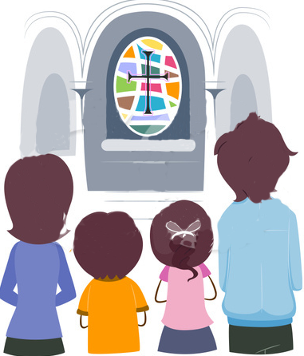

**OTHER NEWS**

We have two more classes before your children receiving their Frist Holy Communion.

**I belong Book**

Please ensure that you child is completing the chapters in the book and that they are up to date.

**Final Session**

The children do not need to bring their books for the final session as they will be involved in making their banners that will be displayed on the day of their First Holy Communion and will be taken to church so Father Keith can explain and show the children what goes on in the life of the church.

You will need to collect your child from church on that day.

Cherie: 07525224423

**This Week**

This week we have moved onto the chapter

‘“Do this in memory of me”

We have been thinking about how when we gather to celebrate the Mass, we are remembering Jesus celebrating the last supper. When we go to mass, Jesus is inviting us to share a special meal with him. The food we eat when we gather around Jesus’ table is food to make our hearts strong. The more we eat this food the more like Jesus we will become.

We have thought about the words we hear every week at mass during the consecration- exactly the same words used at the last supper.

It would be lovely if you could encourage your child to listen hard during mass for those special words.

The food we eat when we gather around Jesus’ table is food to make our hearts strong. The more we eat this food the more like Jesus we will become.

**Please have a go at completing pages**

**94- 104.**

.

Prayer

God made you and God made me,  
He made the world for us to see.  
God loves you and long ago,  
He sent his Son to tell us so.  
  
Jesus showed us many things,  
To love and share and dance and sing.  
To learn and pray, to help and care,  
He promised he'd always be there.  
  
He died but then came back to life,  
Let's celebrate for he's alive!

**.**

God O